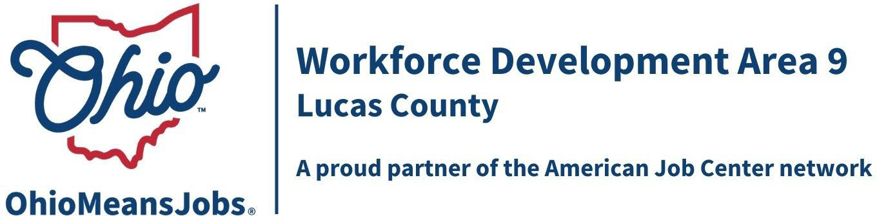
Identity and Employment

Eligibility Policy

Policy Number: 2016-10.27.1-IEEP Effective Date
This policy will go into effect immediately upon passage.

Purpose
The Workforce Innovation and Opportunity Act Section 188 (a) (5) states: " Participation in programs and activities or receiving funds under this title shall be available to citizens and nationals of the United States, lawfully admitted permanent resident aliens, refugees, asylees, and parolees, and other immigrants authorized by the Attorney General to work in the United States."
In order to participate in registered WIOA services, customers will be required to provide documentation that establishes identity and employment eligibility. The Ohio Department of Job and Family Services has established multiple options for providing proof of service eligibility in Workforce Innovation and Opportunity Act Policy Letter (WIOAPL) 15-07.3. This policy defines processes and forms to be used when determining Authorization to Work as well as eligibility for Adult, Dislocated Worker and Youth programs. WIOAPL 15-07.3 will be used by Lucas County Area 9 as a guide for determining eligibility until modified at either the State or Federal levels or the Lucas County Workforce Development Board passes local policy that is more restrictive than existing policy.
Background
WIOA establishes general and specific program eligibility criteria. As recipients of WIOA Title I, Subtitle B funds, the ODJFS Office of Workforce Development (OWD), the local workforce development areas, and Comprehensive Case Management and Employment Program (CCMEP) lead agencies are required to maintain and report accurate program and financial information.
Workforce Service Provider Requirements
As the designated lead agency for Ohio Workforce Area 9 (Lucas County or Area 9), the Lucas County Department of Workforce Development (LCDWD) will verify that all WSPs utilizing Area 9 WIOA funds verify participant eligibility requirements through an examination of documents or by using one or more of the additional methods of source documentation as described in the Allowable Documentation section of this policy.
Documentation requirements to support WIOA adult and dislocated worker eligibility are tied to the level of services provided to the participant. For adults and dislocated workers receiving only basic career services which do not trigger participation in the WIOA program, the Area 9 WSPs may accept information provided by these individuals at face value to complete the basic intake process without requiring source documentation. Documentation requirements increase for participants who receive basic career services triggering participation, individualized career services, or training services.
Allowable Documentation
A list of Allowable Source Documentation for WIOA Program Eligibility is provided by two sources:
Federal:
Form I-9, Lists of Acceptable Documents (see attached) or website: https://www.uscis.gov/sites/default/files/files/form/i-9.pdf (page 9 of 9)
State of Ohio:
Allowable Source Documentation - Attachment A to WIOAPL 15-07.3
SourceDocumentationChart(1).pdf
Definitions
Comprehensive Case Management and Employment Program (CCMEP): An integrated intervention program that combines Temporary Assistance for Needy Families and the WIOA youth program to provide employment and training services to individuals ages 14 through 24 years.
Lead agency: The local participating agency designated by the board of county commissioners to administer CCMEP.
Registration: The process of collecting information to support a determination of eligibility for the WIOA adult, dislocated worker, and youth programs. This information may be collected through methods, including electronic data transfer, personal interview, or an individual's application.
Workforce Service Providers (WSPs): Local areas, career services providers, youth program providers, and CCMEP lead agencies that carry out a workforce development activity or program.

