MICHAEL D. ASHFORD
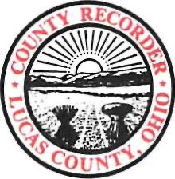

LUCAS COUNTY RECORDER
ONE GOVERNMENT CENTER SUITE 700
TOLEDO, OH 43604-2257
TELEPHONE 419-213-4400
FAX 419-213-4284
RECORDER@CO.LUCAS.OH.US

Date:__________________
On January 6, 2009, SB 248 was signed into law with an effective date of April 6, 2009. This bill creates a public record exemption on DD-214’s for a period of 75 years.
Only authorized parties can view and receive complete copies. All others will be allowed to view and receive a copy that shows the veteran name, rank, date of birth, date of discharge and type of discharge.
Please designate the category that grants you authorization to view the un-redacted DD-214.
_____ Requesting Veteran
_____ County Veteran’s Service Officer or his/her designee
_____ Attorney-in-fact
_____ Agent or Representative of the person who is the subject of the DD-214
_____ Person authorized by a court order
_____ Executor, Administrator or Heir of an estate

_____________________________
Print Name (Requesting Person) Veteran’s Name (If not Veteran Requesting)

Signature (Requesting Person)

Reference # of DD-214 (For Recorder Use)

Request Completed By: ___________________
Date Completed By:______________________

