MICHAEL D. ASHFORD
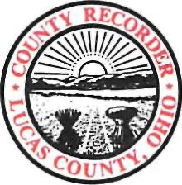

LUCAS COUNTY RECORDER
ONE GOVERNMENT CENTER SUITE 700
TOLEDO, OH 43604-2257
TELEPHONE 419-213-4400
FAX 419-213-4284
RECORDER@CO.LUCAS.OH.US

Date:__________________
On January 6, 2009, SB 248 was signed into law with an effective date of April 6, 2009. This bill creates a public record exemption on DD-214’s for a period of 75 years.
Only authorized parties can view and receive complete copies. All others will be allowed to view and receive a copy that shows the veteran name, rank, date of birth, date of discharge and type of discharge.
Please fill in the following and attach this document to your letterhead showing that you are an authorized funeral director or designee of the funeral home. This will allow you to view the un-redacted DD-214.

Funeral Director or Designee (Print Name) Phone Number

Funeral Director or Designee (Signature) Fax Number

Copies to be sent electronically
Veteran’s Printed Name

E-Mail Address

Veteran’s Date of Birth

Reference # of DD-214 (For Recorder Use)

Request Completed By: ___________________
Date Completed By:______________________

